Navigating the Order Fulfillment Maze: Leveraging Neural Networks to Enhance Amazon's Supply Chain Efficiency

Astha Awale  
*Faculty of Business*  
*Humber College*Toronto, Canada  
astha.awale@gmail.com  
   
Meutia Putri  
*Faculty of Business*  
*Humber College*Toronto, Canada  
Mvtiaree@gmail.com  
  
  
Anjali Patel   
*Faculty of Business*  
*Humber College*Toronto, Canada  
anjali.patel199899@gmail.com  
  
  
Sairohit Chowdhary  
*Faculty of Business*  
*Humber College*Toronto, Canada  
sairohitchowdhary@gmail.com

***Abstract*—The COVID-19 pandemic has had a profound impact on various aspects of supply chain management, including order fulfillment. This study aims to predict the fulfillment status of orders placed by Amazon, utilizing a Artificial Neural Network classification model. Our analysis demonstrates the successful application of this model, achieving an impressive accuracy rate of 98.93%. This highlights the valuable contribution of machine learning models in addressing the challenges faced by businesses for supply chain management and the e-commerce industry as a whole. This model can be useful for Amazon as a strategic supply chain management tool for a competitive advantage by improving order management system , resource allocation and process optimization, which in-turn will promote the efficiency and timeliness of order fulfillment and contribute to the success of Amazon in the ever-changing landscape of the e-commerce industry maze.**

# Introduction

In supply chain management, order fulfillment refers to the procedure of ordering products and receiving them in the warehouse as per the exact quantity and value ordered. When an organization places an order, the order fulfillment process begins, and it finishes when they get the order from the vendors. For businesses to succeed in the fast-paced world of e-commerce, accurate and prompt order fulfillment is essential.

For Amazon as an organization, it is crucial to guarantee that orders are processed, dispatched, and delivered on time to their customers. In order to achieve that Amazon needs to ensure their inventory levels are at the optimum level i.e. Amazon needs to order products from their vendors in-time and in the correct quantity. Given the many factors and complexities involved in the order fulfillment process, it can be challenging to anticipate the fulfillment status of the orders placed by Amazon with accuracy.[1]

Some of the most significant issues with order fulfillment are not warehouse-related. In recent years, a capacity bottleneck has affected many organizations. Even if the COVID-related backlog has subsided, these problems still arise often, and shippers may experience longer than anticipated transit durations.[2]

Another challenge is vendors do not adhere to the receiving warehouse's criteria for mixed commodities, unit of measure accuracy, label requirements, and pallet dimensions and stacking restrictions. As a result, the organization’s like Amazon’s inventory department must repackage or relabel things, which delays the process and there is delay in putting the ordered quantity in the system as ready-to-sell inventory.[2]

Therefore, the business problem is to develop a predictive model that can determine the fulfillment status of the orders placed by Amazon and receive the products from the vendors on-time and in the correct quantity, helping streamline operations and optimize Amazon’s order processing.

The objective is to build a machine-learning model that can accurately predict the fulfillment status of the orders placed by Amazon based on the available features. This predictive model will enable proactive order management, resource allocation, and process optimization to ensure timely and efficient fulfillment.

The paper is structured in the following manner: Section II contains the literature survey related to the field of order fulfillment. Section III covers the description of the dataset. In Section IV, data preprocessing, Section V, the implementation of Neural Network algorithm. Section VI, evaluation of the model, and Section VII specifies the interpretation of the results and conclusion.

# Literature Review

For order fulfillment prediction, there are several researches performed by authors using datasets from different countries and have published academic papers to improve supply chain for businesses in today’s world of e-commerce. The following are the excerpts from few different papers:

Wang, Y., & Zhang, R. (2021). "Applying Artificial Neural Networks to Optimize Supply Chain Management: A Review." International Journal of Production Research.[3]

This paper provides a comprehensive review of the application of artificial neural networks (ANNs) in optimizing supply chain management. It explores various aspects of supply chain optimization, including demand forecasting, inventory management, and order fulfillment. The authors highlight the potential of ANNs in improving supply chain efficiency and propose strategies for integrating ANNs into supply chain decision-making processes.

Liu, Y., & Zhai, L. (2020). "Machine Learning Techniques for Order Fulfillment Prediction in E-commerce Supply Chain." Journal of Industrial Information Integration.[4]

This study focuses specifically on order fulfillment prediction in e-commerce supply chains. It investigates different machine learning techniques, including neural networks, for predicting order fulfillment status based on historical data. The authors evaluate the performance of these techniques and discuss their potential benefits in optimizing e-commerce supply chain operations.

Goyal, S., & Gunasekaran, A. (2020). "Supply Chain Management in the Age of Artificial Intelligence: A Review." International Journal of Production Research.[5]

This review paper provides insights into the integration of artificial intelligence (AI) technologies, including neural networks, in supply chain management. It discusses how AI-driven approaches can enhance decision-making processes, optimize inventory management, and improve order fulfillment efficiency. The authors highlight the role of neural networks in enabling accurate demand forecasting and fulfillment prediction, thereby transforming supply chain operations.

Wang, X., & Li, C. (2019). "Application of Neural Network in Order Fulfillment Prediction for E-commerce Logistics." In 2019 2nd International Conference on Industrial Artificial Intelligence (IAI). [6]

This conference paper focuses on the application of neural networks for order fulfillment prediction in e-commerce logistics. It presents a case study where a neural network model is developed and trained using historical data to predict order fulfillment status accurately. The authors discuss the effectiveness of the neural network approach and its potential for optimizing e-commerce logistics processes.

Chen, L., & Li, Y. (2018). "A Deep Learning-Based Order Fulfillment Time Prediction Approach for E-commerce Logistics." International Journal of Production Research.[7]

This research article proposes a deep learning-based approach for predicting order fulfillment time in e-commerce logistics. The study utilizes recurrent neural networks (RNNs) to capture temporal dependencies in order fulfillment data and improve prediction accuracy. The authors demonstrate the effectiveness of the proposed approach and discuss its implications for optimizing supply chain operations.

These references provide valuable insights into the use of neural networks and machine learning techniques for optimizing supply chain management, particularly in the context of order fulfillment prediction. They highlight the potential of AI-driven approaches to revolutionize supply chain operations, enhance efficiency, and improve customer satisfaction in companies like Amazon.

# Source Of The Data and Description Of The Dataset

The Amazon dataset was obtained from the dataset uploaded by Professor Salam Ismaeel on Humber College Blackboard [8] titled "Amazon 2018”. The dataset contains historical order made by amazon to its vendors. In the realm of Amazon's business operations, an individual or entity operating as an Amazon vendor assumes the role of a manufacturer or supplier, bearing the responsibility of transporting goods to Amazon's warehousing facilities. The original dataset includes 13 variables with a total of 196798 entries that can potentially impact the fulfillment status of the orders. The description of the dataset can be referred to in Table I below:

Table I: Description Of Dataset

| **Variable Name** | **Data Type** | **Description** |
| --- | --- | --- |
| AMZN_YR_WK | int64 | Unknown Code |
| Department | int64 | Department Code |
| VendorName | object | Name of Amazon Vendors |
| Purchase Order | int64 | Purchase Order ID |
| DC | int64 | Unknown Code |
| Original Delivery Date | object | Planned delivery date |
| Actual Delivery Date | object | Actual date of delivery |
| Gate Time | object | Shipment time |
| Ordercases | int64 | Quantity of order placed |
| Rcvd Cases | object | Quantity of order received |
| Non Compliant Qty | int64 | Incorrect quantity of merchandise received |
| Compliant % | object | Percentage of correct merchandise received in the proper quantity |
| Status | int64 | 0 – Unfulfilled order  1 – Fulfilled order |

The dataset will undergo procedures such as data cleansing, data preprocessing, and visualization to extract meaningful information that will guide the construction of a neural network predictive model. In the subsequent segment of this report, we will elaborate the data preprocessing techniques used to prepare our data for. Moreover, we will deliberate on the constraints of the model and pro building a Neural Network Model to predict.

# Data Preprocessing

Data pre-processing is an integral component of data preparation. It involves performing various operations on raw data to render it suitable for subsequent data processing tasks such as data mining, machine learning, and other data science activities. The objective of data pre-processing is to transform the data into a structured format that can be efficiently and effectively processed within the machine learning and AI development pipeline. Since real-world data is often disorganized and originates from diverse sources, including individuals, business operations, and software programs, applying data pre-processing techniques becomes essential in the early stages of developing machine learning and AI applications. This process ensures the generation of reliable and accurate insights [9].

1. *Converting Incorrect Data Types*

Converting the data type to the appropriate format before performing a neural network prediction is crucial because Neural networks rely on mathematical operations to process data and make predictions. Different data types have different mathematical properties and limitations. Converting data from object type to numerical types such as int or float enables the neural network to perform mathematical operations accurately and efficiently. Moreover, Neural networks interpret and learn patterns from input data. Converting data from object type to a suitable format, such as numerical or datetime, ensures that the features are represented effectively in a way that captures the underlying patterns and relationships. This enhances the network's ability to extract meaningful information and make accurate predictions [10]. The variables in which data conversion was performed are as follows:

Table 2: Data type after conversion

| **Variable Name** | **Data Type** | **Method/Library Used** |
| --- | --- | --- |
| VendorName | Object to int64 | LabelEncoder |
| Original Delivery Date | Object to datetime64 | datetime |
| Actual Delivery Date | Object to datetime64 | datetime |
| Non Compliant Qty | int64 to float64 | drop () 1 row consisting of ‘#DIV/0!’ |
| Compliant % | Object to float64 | astype |

Furthermore, to help the neural network predict the status of fulfillment orders, a new column named “Difference in Delivery Days,” consisting of the difference between the original delivery days and the actual delivery days, was created by subtracting the actual delivery date with the original delivery date. The total columns of our dataset consist of 196,797 rows and 14 columns. The new column, along with “Non Compliant Qty,” “VendorName,” “Ordercases,” and “Compliant %” columns, are chosen for the Neural Network input variables. In contrast, the column “Status,” as in the fulfillment status, will be used for the output variable.

# Implementation

A neural network is a computational model inspired by the structure and function of the biological brain. It consists of interconnected nodes, called neurons or units, arranged in layers. Each neuron receives inputs, applies weights to them, sums them up, and passes the result through an activation function to produce an output. The connections between neurons are represented by weights that are adjusted during training using algorithms like backpropagation to minimize the error between predicted and actual outputs. Neural networks can have different architectures, including feedforward, convolutional, recurrent, and deep neural networks, and are widely used for tasks like pattern recognition, classification, and regression.[11]

Here, a feedforward neural network is used with a logistic function as an activation function. The basic formula for a neural network with logistic function is as follows:

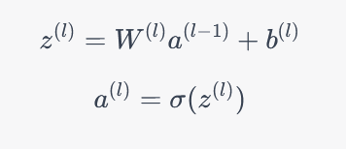

fig 1. Formula of feedforward neural network[12]

Where:

* z(l) represents the input to the i-th layer, which is obtained by multiplying the weights W(l) with the activations a(l−1) of the previous layer and adding the bias term b(l).
* a(l) is the output or activation of the l-th layer, obtained by applying an activation function σ to z(l).
* Activation function formula:

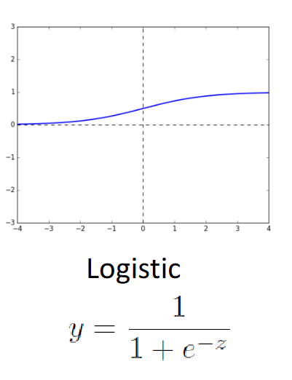

Fig 2: Graph and formula of logistic function[13]

The role of an activation function in a neural network is to introduce non-linearity and enable the network to learn complex patterns and relationships in the data.

Logistic function is used when the model predicts probability, Since probability only ranges from 0 to 1.

# Model Architecture

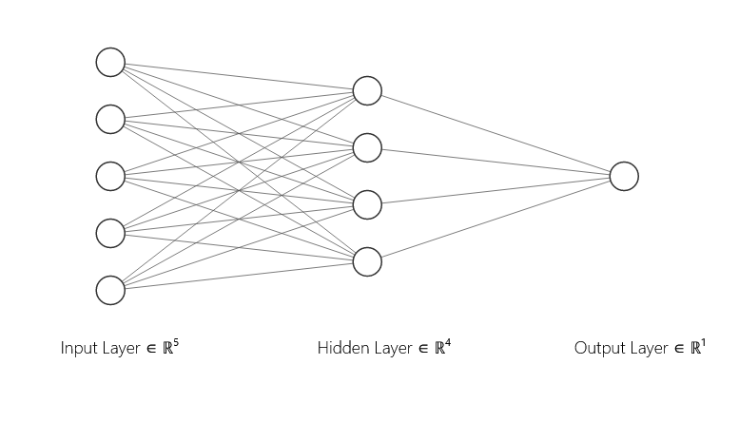

Fig: 3 Architecture of Neural network model

Input Layer: The input layer consists of nodes that represent the features or input variables of the problem. Each node in the input layer corresponds to a specific input feature.

Hidden Layer: The hidden layer is where the 4 neurons are located. Each neuron receives inputs from all the nodes in the input layer. The connections between the input layer and the hidden layer are represented by weights. The 4 neurons in the hidden layer perform computations on the weighted inputs and apply an activation function to produce their respective outputs.

Output Layer: The output layer consists of a single node or multiple nodes, depending on the specific problem. Each node in the output layer represents a possible class or the predicted value. The output layer receives inputs from the hidden layer and produces the final output.

The number of neurons in the hidden layer (in this case, 4 neurons) represents the level of complexity and capacity of the neural network to learn and represent the underlying patterns in the data. Each neuron in the hidden layer applies weights to the inputs, performs a computation, and applies an activation function to introduce non-linearity.

Justifying the number of hidden layers in a neural network for predicting fulfillment status for Amazon Vendor Orders with a dataset of almost 20000 rows and 8 columns can be approached as follows[14]:

1. Dataset Size and Complexity: The dataset consists of 196,797 rows and 14 columns, which provides a substantial amount of data for training the model. While the dataset is moderately large, it does not necessarily require a highly complex neural network architecture. The selected architecture with one hidden layer and four neurons strikes a balance between capturing the necessary complexity in the data and avoiding overfitting. It provides sufficient capacity to learn the underlying patterns and relationships in the supply chain fulfillment problem without overwhelming the model.
2. Interpretability and Explainability: In supply chain management, interpretability and explainability are crucial factors for decision-making and stakeholder buy-in. By opting for a simpler architecture, the model becomes more transparent and easier to interpret. The relationships and factors influencing supply chain fulfillment can be better understood by stakeholders, allowing them to make informed decisions based on the model's predictions. This enhances trust and confidence in the model's recommendations.
3. Computational Efficiency: Training a neural network with multiple hidden layers and a large number of neurons can be computationally intensive, especially with a dataset of this size. The chosen architecture of one hidden layer and four neurons significantly reduces the computational complexity and training time compared to more complex architectures. This allows for faster experimentation, model optimization, and practical implementation. Additionally, it ensures that the model remains scalable, enabling it to handle larger datasets or accommodate future expansions of the supply chain fulfillment problem.[14]

# model evaluation

Different machine learning algorithms have specific evaluation methods. For Neural Network Algorithm, we will use confusion matrix to check the accuracy and its performance.

The confusion matrix summarizes the correct and incorrect classifications of the model with the number of true positives (TP), false positives (FP), true negatives (TN), and false negatives (FN) on the dataset. The rows represent the actual class of price while the columns represent the predicted class of price produced by the model. Accuracy computed from the validation data is used to evaluate the model’s ability to predict new data and estimate future classification errors.

Table II: Confusion Matrix and accuracy of Neural Network Algorithm (NN) – Training Data

|  | Prediction |  |
| --- | --- | --- |
| Actual | 0 | 1 |
| 0 | 73293 | 1280 |
| 1 | 0 | 43505 |

Confusion Matrix (Accuracy 0.9892)

Talking about the Neural Network algorithm, the accuracy of our training data is 0.9892. We further evaluate the performance of the Neural Network Algorithm by using the cross-validation on the validation data because it provides a more accurate estimate of the performance of the Neural Network algorithm and reduces over-fitting of the model

Table III: Confusion Matrix and accuracy of Neural Network Algorithm (NN) – Validation Data

|  | Prediction |  |
| --- | --- | --- |
| Actual | 0 | 1 |
| 0 | 48828 | 842 |
| 1 | 0 | 29049 |

Confusion Matrix (Accuracy 0.9893)

Now, coming to our validation data, the model's accuracy with cross-validation is 0.9893, slightly higher than the accuracy we get without the cross-validation technique.

True Negatives (TN): The model correctly predicted 48,828 instances as 0 (Unfulfilled orders) when the actual label was also 0. This indicates that the model accurately identified unfulfilled orders, which is crucial for effective order management and inventory control.

True Positives (TP): The model correctly predicted 29,049 instances as 1 (Fulfilled orders) when the actual label was also 1. This indicates that the model accurately recognized and classified fulfilled orders. This is an important outcome as it ensures that customers receive their orders as expected.

False Negatives (FN): The confusion matrix states that there were no false negatives, meaning the model did not mistakenly classify any actual fulfilled orders as unfulfilled. This indicates that the model effectively captured all instances of fulfilled orders, preventing any potential missed opportunities or delays in order fulfillment.

False Positives (FP): The model predicted 842 instances as 1 (Fulfilled orders) when the actual label was 0 (Unfulfilled orders). This represents false positives where the model wrongly classified some unfulfilled orders as fulfilled. While the number of false positives is relatively low compared to the true negatives and true positives, it may still lead to incorrect order processing and potential customer dissatisfaction.

Overall, the neural network demonstrates good performance in identifying unfulfilled orders (TN) and fulfilled orders (TP), achieving high accuracy in these categories. However, it requires further improvement to reduce the occurrence of false positives (FP), ensuring more accurate classification of unfulfilled and fulfilled orders.

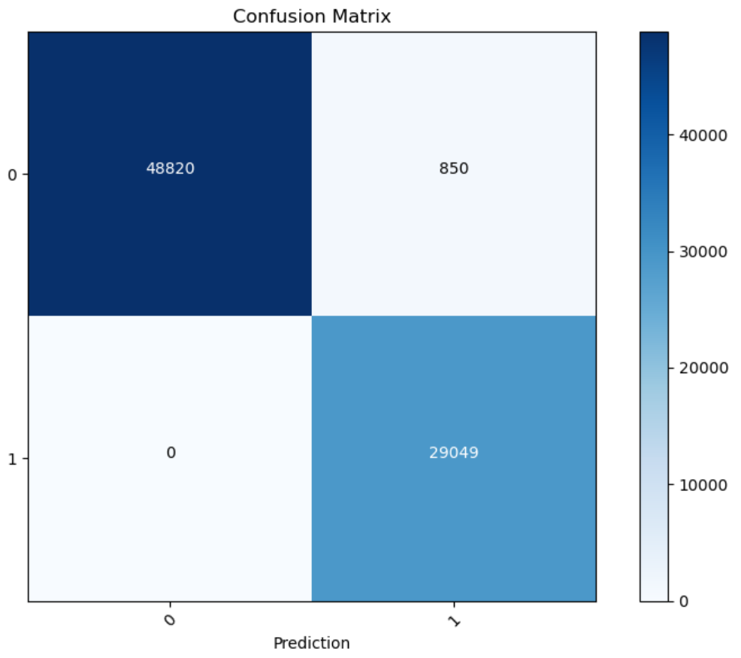In conclusion, the Neural Network Algorithm does a good job of predicting whether new data will be classified as fulfilled or unfulfilled with an accuracy of 98.93% .

# Conclusion

In this research, the focus is on addressing the challenges of order fulfillment faced by Amazon. The objective is to develop a predictive model using Neural Network model to accurately determine the fulfillment status of orders placed by Amazon. This model aims to help streamline operations and optimize the order processing by predicting whether an order will be fulfilled or unfulfilled based on available features.

The results of the neural network confusion matrix shows that the model performed well in predicting both fulfilled and unfulfilled orders. In the validation data, the neural network model correctly predicted 48828 instances as 0 (Unfulfilled orders) when the actual label was also 0. These are the true negatives (TN). It correctly predicted 29049 instances as 1 (Fulfilled orders) when the actual label was also 1. These are the true positives (TP). There were no false negatives (FN), indicating that the model correctly identified all the fulfilled orders. There were 842 false positives (FP), where the model predicted an order to be fulfilled (1) when it was actually unfulfilled (0). It correctly identified a significant number of instances as unfulfilled orders (true negatives) and fulfilled orders (true positives). All in all, the model accurately identified all the fulfilled orders. However, there were a small number of false positives, where the model predicted an order to be fulfilled when it was actually unfulfilled.

The literature review previously done had emphasized the significance of neural networks and machine learning techniques in optimizing supply chain management and addressing the challenges of order fulfillment in the e-commerce industry. As a result, the developed predictive model in this present study further exhibits promising characteristics in terms of effectively ascertaining the fulfillment status of orders placed by Amazon. This model has the potential to facilitate proactive order management, resource allocation, and process optimization, ultimately improving the efficiency and timeliness of order fulfillment. Further research and refinement of the model can help address the challenges faced in accurately predicting the fulfillment status of orders and contribute to the success of organizations in the fast-paced world of e-commerce.

##### References

1. Warehouse Operations (2023, April 30). What is order fulfillment? How does it work?. River Systems.

<https://6river.com/what-is-order-fulfillment/>

1. [Parisa Kamali](https://www.imf.org/en/Blogs/authors?author=Parisa%20Kamali), [Alex (Shiyao) Wang](https://www.imf.org/en/Blogs/authors?author=Alex%20Shiyao%20Wang) (2021, October 25). Longer Delivery Times Reflect Supply Chain Disruptions. Chart of the Week

<https://www.imf.org/en/Blogs/Articles/2021/10/25/longer-delivery-times-reflect-supply-chain-disruptions>

1. Y. Wang and R. Zhang, "Applying Artificial Neural Networks to Optimize Supply Chain Management: A Review," International Journal of Production Research, vol. 59, no. 10, pp. 2956-2976, 2021.
2. Y. Liu and L. Zhai, "Machine Learning Techniques for Order Fulfillment Prediction in E-commerce Supply Chain," Journal of Industrial Information Integration, vol. 17, p. 100121, 2020.
3. S. Goyal and A. Gunasekaran, "Supply Chain Management in the Age of Artificial Intelligence: A Review," International Journal of Production Research, vol. 58, no. 16, pp. 4714-4741, 2020.
4. X. Wang and C. Li, "Application of Neural Network in Order Fulfillment Prediction for E-commerce Logistics," in 2019 2nd International Conference on Industrial Artificial Intelligence (IAI), pp. 149-152, IEEE, 2019.
5. L. Chen and Y. Li, "A Deep Learning-Based Order Fulfillment Time Prediction Approach for E-commerce Logistics," International Journal of Production Research, vol. 56, no. 8, pp. 3076-3089, 2018.
6. Amazon 2018 dataset, Humber College Blackboard, Machine Learning Week 3 – Upload (2016). Available: <https://learn.humber.ca/ultra/courses/_226296_1/outline>
7. G. Lawton, “Data preprocessing: Definition, key steps and concepts,” Data Management, <https://www.techtarget.com/searchdatamanagement/definition/data-preprocessing#:~:text=What%20is%20data%20preprocessing%3F,for%20the%20data%20mining%20process>
8. K. E. Koech, “The Basics of Neural Networks (Neural Network series) - part 1,” Medium, <https://towardsdatascience.com/the-basics-of-neural-networks-neural-network-series-part-1-4419e343b2b>
9. Goodfellow, I., Bengio, Y., & Courville, A. (2016). Deep Learning. MIT Press.
10. Goodfellow, I., Bengio, Y., & Courville, A. (2016). Deep Learning. MIT Press. Chapter 6: Deep Feedforward Networks.
11. Machine learning week 2 lecture notes, Humber college
12. He, K., Zhang, X., Ren, S., & Sun, J. (2015). Deep Residual Learning for Image Recognition. Proceedings of the IEEE Conference on Computer Vision and Pattern Recognition
13. Goodfellow, I., Bengio, Y., & Courville, A. (2016). Deep Learning. MIT Press
14. Simonyan, K., & Zisserman, A. (2015). Very Deep Convolutional Networks for Large-Scale Image Recognition. International Conference on Learning Representations